**Niroop Katta, Sr Salesforce Consultant** 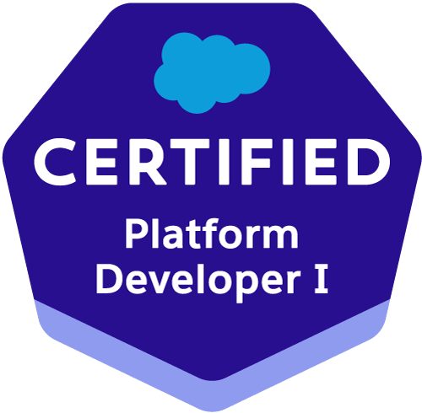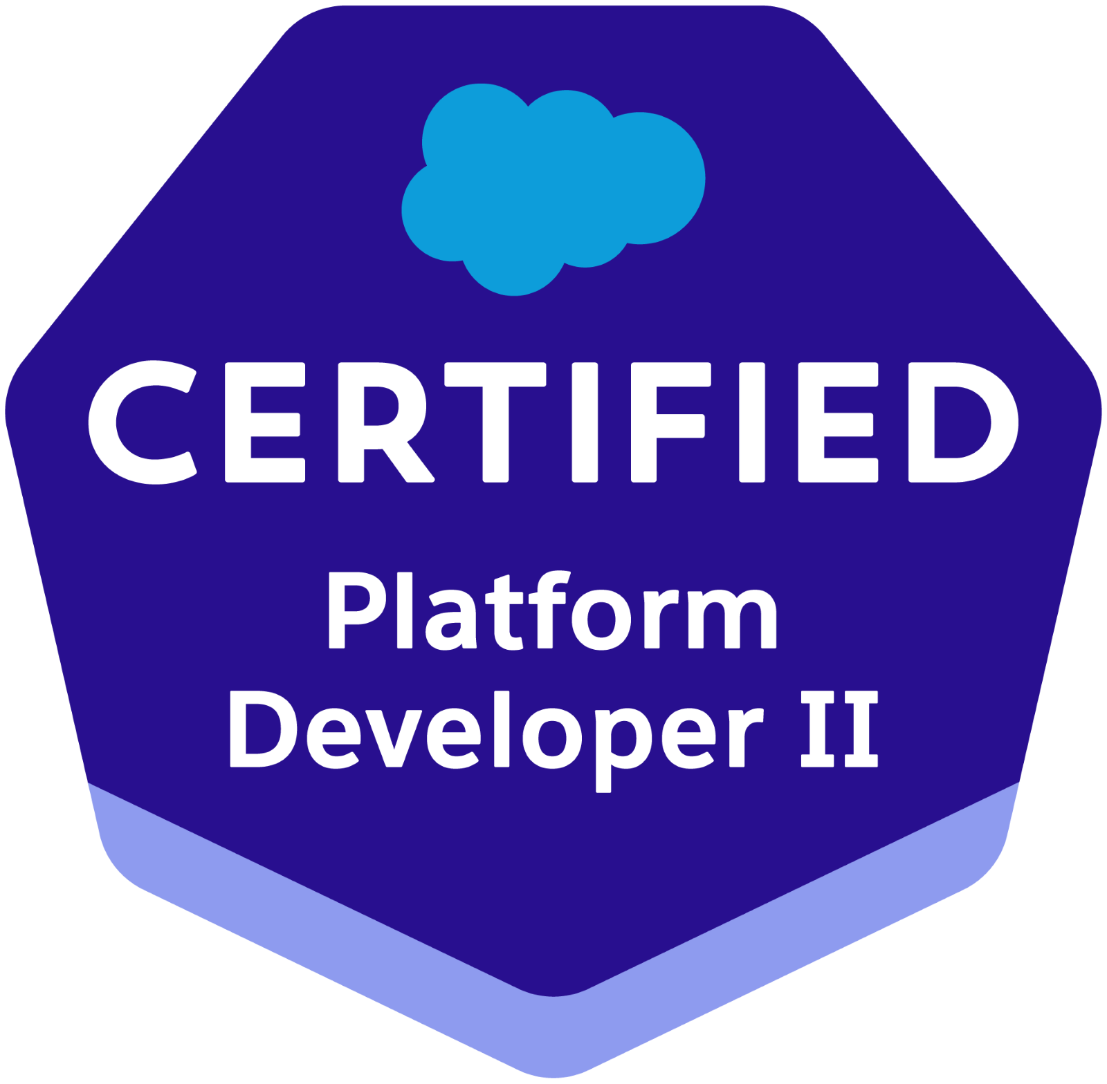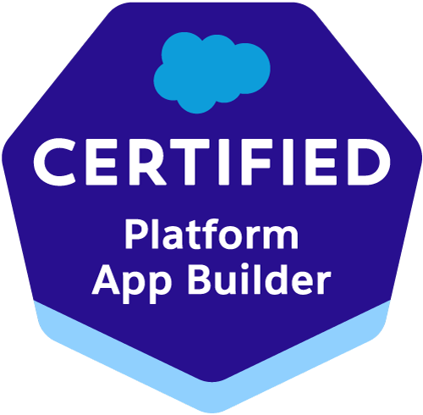

**<https://trailblazer.me/id/niroop84>**

**Professional Summary:**

* Around 10 years of progressive experience as a Salesforce Developer/Administrator, Java/Web Developer with a consistent track record of excellent performance.
* 6x Certified Salesforce Developer/Administrator.
* Extensive experience across various stages of the Software Development Life Cycle (SDLC), including analysis, requirement gathering, development, deployment, and maintenance of web-based, object-oriented enterprise applications..
* Expertise in **Salesforce Development**, including Lightning Web Components, Lightning Applications, Aura Component framework, Apex Classes, Apex Triggers, Batch Jobs, Asynchronous Apex, VisualForce Pages, Controllers, Components, Tabs, Apex Web Services, Integrations, Field Service Lightning, Lightning Message Service, and Lightning Data Service.
* Proficient in dealing with functionalities related to **Sales cloud**, **Health Cloud,** **Marketing cloud**, **Community**/**Experience** **cloud**, **Service Cloud** and AppExchange applications.
* Expertise on **Lightning Web Components**, Lightning Message Services, Lightning Data Services.
* Experience in SFDC Development implementing the **APEX Classes**, **APEX Triggers**, **Asynchronous Apex**, Apex Web Services.
* Extensive experience working on **Integrations** using **REST** and **SOAP** APIs.
* Configured and customized the **Salesforce Mobile App** for enhanced user experience.
* Experienced in building Lightning components using both **Lightning Web Components** (LWC) and **Aura** **Components**.
* Proficient in **Salesforce Administration**, including customization and implementation of objects, profiles, roles, security settings, sharing rules, applications, custom fields, Flows, Process Builder, page layouts, Flexi Pages, Approval Processes, Workflow Rules, Validation Rules, reports, dashboards, tasks, events, activities, and email generation.
* Developed **Apex Classes**, **Apex Triggers**, and **Test Classes** for unit testing to meet functional application needs.
* Expertise in implementing Salesforce Security Model, including Organization-Wide Defaults (OWD), sharing rules, profiles, and roles.
* Having a good understanding of Salesforce **Governor Limits**, **best practices** ability to do code reviews and enforce best practices.
* Experienced with **DevOps** **Continuous Integration and Continuous Delivery** is achieved by the **Git** , **JIRA**, **Jenkins**, **CI/CD** process.
* Expertise working with **Java/UI technologies** like **JavaScript**, **Java**, **HTML**, CSS, Jquery, **Adobe Experience Manager** (**AEM**), SQL, XML, and JSON.
* Experience developing applications on **spring framework** by utilizing its features like **Spring Boot**, Spring Dependency Injection, Spring Beans, Spring Security, Spring JPA, Spring Web flow using **MVC**.
* Experience in developing **Web Applications** which have integrated several functional capabilities like, Adobe Experience Manager (**AEM**) **Web Content Management system** (**CMS**), **Digital Asset Management** (**DAM**), Identity & Access Management, Social Media, Search, SEO etc.
* Implemented best practices in version control, continuous integration, and continuous delivery using Copado to streamline deployment workflows.
* Utilized Copado’s metadata deployments and data deployments tools to ensure seamless integration and data integrity across Salesforce instances.
* Designed and executed data migration strategies using MuleSoft, SOSL, and SOQL statements within Governor Limits.
* Extensive experience on creating **Screen Flows**, **Auto Launched Flow**, **Record Trigger Flows** and **Scheduled Flows**.
* Hands on experience in **Community**/**Experience Cloud** to enable the portal users to perform sales operations.
* Expertise in **Testing** process, ability to develop functional test plans, test scenarios, test cases, test scripts, coordination, escalation, prioritizing the bugs and user acceptance testing.
* Made **Documentation** on various functionalities and used **Confluence** for documentation.
* Experience in Lightning Framework, Components, Apps,  **lightning migration**.
* Worked on Internal & External systems integration **SOAP**, **REST Web services** and Enterprise tools, Metadata API, Schema classes.
* Experience in **Salesforce CPQ** Implementation and Configuration. Configured Guided selling, Product Rules, Product Bundles, Discount Schedules, OOB Quote Templates.
* Expertise in **Data** **Integrations** with third party systems.
* Implemented a comprehensive suite of RESTful APIs to support standard CRUD operations for the product module, and collaborated on the design and development of a **GraphQL** API.
* Proficient in **Data Migration** from legacy systems to Salesforce using **Data Loader**, I**mport wizard** and Bulk API.
* Expertise in diverse facets of business analysis including Requirement gathering, Project Management, Change Management, Release Management and Configuration Management.
* Strong understanding of fundamental business processes, excellent Communication and interpersonal skills with ability to work well in a dynamic team environment.
* Worked closely with stakeholders, including business analysts, administrators, and end-users, to gather and refine requirements.

**Education & Certifications:**

* Master of Science in Computer Science, University of Central Missouri.
* Bachelor of Technology in Electronics and Communication Engineering, JNTU.
* Salesforce Certified Administrator - 21792667
* Salesforce Certified Platform Developer 1 - 21781831
* Salesforce Certified Platform Developer 2 - 21901019
* Salesforce Certified JavaScript Developer 1 - 2453681
* Salesforce Certified App Builder - 4060028
* Salesforce Certified Marketing Cloud Email Specialist - 4071040

**TECHNICAL SKILLS:**

|  |  |
| --- | --- |
| Salesforce Technologies | Salesforce CRM, Lightning Web Components Force.com, Apex Language, Apex Classes,Controllers, Apex Triggers, SOQL, SOSL, Asynchronous Apex, Component,Apex Web Services, CPQ, Partner WSDL & Enterprise WSDL,FSL, Flowst, WorkFlow and Approvals, Dashboard, Analytic Snapshots |
| Salesforce Tools | Apex Data Loader, Import Wizard, CPQ, VSCode, Force.com Eclipse IDE Plug-in, Force.com Explorer, Salesforce Extensions, Change Sets, Apex Data Loader, Import Wizard, Data Export. |
| Java/Web Technologies | Java, J2ee, JavaScript, HTML,AEM, CSS, jQuery, Ajax, XML, PL/SQL |
| Languages | Apex, Java, JavaScript, Python, SQL, SOQL, SOSL |
| Database | SQL Server 2008, Oracle, MySQL |
| Web | JavaScript, HTML, AEM, XML, CSS, WSDL, SOAP API, REST API, JSP |
| Tools | VSCode, Jenkins, Git,Ant, Jira, Copado, Rally, HP ALM, Postman, SoapUI,IntelliJ,Eclipse |
| Web Servers | IBM WebSphere 4.x/5.x, Apache Web Server, Tomcat 6.x |

**PROFESSIONAL EXPERIENCE:**

**Client: Cigna, Hartford CT Mar’24 Till date**

**Project: In Home Primary Care**

**Role: Sr Salesforce Consultant**

**Description:** This project focused on migrating the scheduling system from Epic to Salesforce to enhance the appointment booking process and reduce provider travel time.

**Responsibilities:**

* Actively participated in various project activities, including conducting review meetings with business and technical teams, gathering and analyzing requirements, and documenting both functional and non-functional requirements.
* Design and develop solutions on the Salesforce platform to meet business requirements.
* Developed **Lightning Web Components**, Lightning Message Service, Lightning Data Services, Salesforce Lightning Design System, Lightning Components, JavaScript Controllers, and Server-side Controllers.
* Developed Apex classes, Apex Triggers, and Asynchronous Apex (Batch, Future, Queueable, Scheduled), as well as SOQL and SOSL queries to address various functional needs in the application.
* Experienced in developing and managing Flows, Validation Rules, Workflows, and Approval Processes to automate and streamline business processes.
* Integrated Salesforce Org with EPIC and other external systems, ensuring seamless data flow and operational efficiency.
* Worked on integrating the Health Cloud object model with EPIC via AWS to enhance healthcare data management and accessibility.
* Implemented and customized Salesforce **Field Service Lightning** (FSL) to optimize field operations, improving efficiency and productivity.
* Integrated Salesforce FSL with EPIC and other external systems to ensure seamless data flow and coordination between field operations and other business units.
* Refactored and optimized the codebase to significantly enhance the application's performance and efficiency.
* Customized Service Appointments and optimized Routes using Salesforce Maps for improved logistical planning and resource allocation.
* Developed **FSL** configurations such as Service Territories, Work Rules, and Scheduling Policies to enhance resource allocation and scheduling efficiency.
* Led the configuration and customization of **Copado** pipelines, incorporating best practices in CI/CD methodologies to ensure efficient delivery of Salesforce applications.

**Environment:** Force.com Platform, Salesforce DX,Sales Cloud, Community/Experience cloud, Apex,, SLDS, Vlocity, Health Cloud, Copado, Lightning Web Component, Git,CI/CD,HP ALM, SOQL, Confluence, Data Loader, VS Code, Salesforce CLI, JIRA, SOAP, REST.

**Client: Healthfirst, New York Mar’22 Till Feb’24**

**Project: Sales**

**Role: Sr Salesforce Consultant**

**Description:** Healthfirst is a provider-sponsored health insurance company that serves more than 1.2 million members in New York. Healthfirst offers Medicaid, Medicare Advantage, child Health Plus and long term care plans. This project is focused on Sales of Insurance Plans.

**Responsibilities:**

* Involved in various activities of the project, like conducting review meetings with business and technical team, requirement gathering, and analyzing requirements, documenting the functional and nonfunctional requirements.
* Design and develop solutions within the Salesforce platform to address business requirements.
* Developed **Lightning Web Components**, Lightning Message Service, Lightning Data Services, Salesforce Lightning Design System and Lightning Components, **JavaScript Controllers**, Server-side Controllers.
* Developed **Apex classes**, **Apex Triggers**, **Asynchronous Apex**(Batch, Future, Queueable, Scheduled), SOQL , SOSL for various functional needs in the application.
* Experience in developing **Flows**, Validation Rules, Workflows and Approval Processes, Process Builder, Flows for Automated alerts, Flexi Pages, new Tasks, field updates, and Email generation according to application requirements.
* Expertise in **migrating** **Aura** to **Lightning Web Components** which made the Health Insurance process more effective for sales reps.
* Provided **SME support** on **Lightning Web Components** issues/concerns for Healthfirst Insurance Plans in Salesforce Org.
* Designed and customized **Community**/Experience cloud solutions to meet client requirements, including branding, user access, and data integration.
* Developed **Flows**, Time-Dependent **Workflow** Actions, **Email Alerts** and Field Updates.
* Integrated salesforce data with external systems by salesforce **REST** Web Services.
* Worked on the Lightning web components by using the custom metadata types to build the dynamic components using the lightning data services.
* Created Lightning web components (LWC) and apps combining Lightning Design system, Lightning App Builder and Lightning Component features.
* Enabled **Community**/**Experience** cloud for partner users to perform sales operations on Health Insurance Plans.
* ​​Expertise in Configuring Salesforce CRM by adding new features and functionalities to Salesforce Org according to Health Insurance Plans.
* Expertise in **Data** **Integrations** with third party systems like ERP, DocuSign,AWS etc.
* Worked on **Communities/Experience** configured UI/UX for community users.
* Experience with **Vlocity** platform capabilities, including DataRaptors, Integration Procedures, Calculation Matrices and Procedures, OmniScripts, various cards UI framework and building Vlocity custom Templates.
* Good understanding of the Health Cloud Object model for Insurance and Utilization and Integrations.
* Expertise in Vlocity application modules like Insurance, Communications.
* Integrated salesforce data with external systems like DocuSign, AWS Connect, ERP etc using salesforce **REST Web Services**.
* Experience in implementing **Apex Classes**, **Controllers** & **Triggers**, Visual force, Force.com Experience in release management, Sandbox creation, Change Sets, Workbench, GIT, ANT, Visual Studio, Jenkins, SFDX.
* Configured and customized **Salesforce Mobile App**.
* Build each web page according to design, developed custom UI using CSS, HTML, LWC, Visualforce components and used JQuery, JavaScript for front-end validation.
* Implemented code coverage and **Test classes**.
* Experienced with **DevOps** **Continuous Integration and Continuous Delivery** is achieved by the **GitHub**, **JIRA**, **Jenkins**, **CI/CD** process.
* Integrated salesforce with the **MuleSoft** for connecting applications, data sources and APIs, in the cloud.
* **Integrated** salesforce **data** with external systems by salesforce **REST** Web Services.
* Implemented a comprehensive suite of RESTful APIs to support standard CRUD operations for the product module, and collaborated on the design and development of a **GraphQL** API.
* Configure client requirements into Apttus **CPQ** design, leveraging best practices and minimizing the need for custom development.
* Configure Apttus CPQ and Sales Cloud solutions.
* Made **Documentation** on various functionalities and used **Confluence** for documentation.
* New functionalities and **POC**’ are implemented on the project.
* Played an active role in **testing** the application by writing **test cases** for different scenarios.
* Troubleshoot the issues with custom merge processes and **Integrations** with different applications.
* Executed daily build **deployments** in **Jenkins**, troubleshoot any **deployment** **issues** and coordinated with a support team as needed.
* Worked on various test case scenarios involving project functionality.
* Worked on QA testing and ran test scripts in HP ALM.
* Production support.

**Environment:** Force.com Platform, Salesforce DX,Sales Cloud, Community/Experience cloud, Apex,, SLDS, Vlocity, Health Cloud, Copado,Ant, Lightning Web Component, Git,CI/CD,HP ALM, SOQL, Confluence, Data Loader, VS Code, Salesforce CLI, JIRA, SOAP, REST.

**Client: T-Mobile, Bellevue,WA May’21 – Mar’2022**

**Role: Sr Salesforce Developer**

**Project: T-Mobile for Business**

**Description:** T-Mobile for Business specializes in selling bulk plans to companies, providing tailored telecommunications solutions to meet the unique needs of corporate clients.

**Responsibilities:**

* Involved in various activities of the project, like conducting review meetings with business and technical team, requirement gathering, and analyzing requirements, documenting the functional and nonfunctional requirements.
* Followed Agile SCRUM methodology that includes iterative Application Development, two-week Sprints and Backlog and Refinement Meetings.
* Developed **Lightning Web Components**, Salesforce Lightning Design System and Lightning Components, **Aura Framework**, JavaScript Controllers, Server-side Controllers.
* Developed **Apex classes**, **Apex Triggers**, Batch Jobs, Asynchronous Apex, SOQL, SOSL for various functional needs in the application.
* Experience in developing Flows, Validation Rules, Workflows and Approval Processes, process builder, Flows for Automated alerts, new Tasks, field updates, and Email generation according to application requirements.
* Involved in **Integration** of Salesforce.com with external applications by using Web Services API, Metadata API, and SOAP.
* Organized **Marketing Campaigns**, **Campaign Hierarchies**, Lead Queries, Assignment rules, Web-to- Lead and Auto-Response rules.
* Created and implemented marketing campaigns using tools like **Journey Builder**, **Email Studio**, and **Automation Studio**.
* **Integrated** salesforce **data** with external systems by salesforce **REST** Web Services.
* Knowledge of **Community** cloud best practices and customization techniques.
* Optimize and improve the overall runtime of Omni Scripts, DataRaptors and Velocity Integration Procedures using best practices
* Expertise in creating and designing **Community** Pages,and good understanding on Content Management System (**CMS**).
* Coordination of day-to-day email operations, building and segmenting audiences, and creating automated campaigns.
* Worked on the Lightning web components by using the custom metadata types to build the dynamic components using the lightning data services.
* Working closely with the offshore team for the deployments using the **Copado** Console.
* Hand-on experience on **Integration**, specially good Knowledge in JSON and how integration works in Vlocity.
* Good knowledge of omniscript UI modification, Building **Vlocity** custom Templates
* Created **Lightning web components** (LWC) and apps combining Lightning Design system, Lightning App Builder and Lightning Component features.
* Expertise in Configuring Salesforce CRM by adding new features and functionalities to Salesforce Org.
* Used **Jenkins** to do **code builds** from **GitLab** to perform salesforce **Deployments**.
* Used Data Loader to insert, update, and bulk import or export of data from Salesforce.com objects and to read, extract and load data from comma separated values (CSV) files.
* Designed salesforce service cloud console to enhance productivity with dashboard like interface.
* Developed **Workflow Rules**, Time-Dependent **Workflow Actions**,**Email Alerts** and Field Updates.
* Extensively worked with **Data Loade**r and Bulk API to import or export the data from Salesforce.com objects in very large volume.
* Involved in creating various releases and promotions with multiple environments for the production deployment using Copado.
* Troubleshoot the issues with custom merge processes and **Integrations** with different applications.
* Integrated salesforce data with external systems by salesforce **REST** Web Services.
* Worked with the user group for requirement gathering throughout the planning and implementation and designed the data model to transform the existing business process to Salesforce.
* Configured Service Cloud to handle Case management, Email-to-case routing, sharing settings in queue-based model.
* Experienced with **DevOps** **Continuous Integration and Continuous Delivery** is achieved by the **GitLab** **CI/CD** process.
* Expertise working with **Java/UI technologies** like **JavaScript**, **Java**, HTML, CSS, Jquery, **Adobe Experience Manager** (**AEM**), Oracle SQL,PostgreSQL, XML, and JSON.
* Developed application on **spring framewor**k by utilizing its features like **Spring Boot**, Spring Dependency Injection, Spring Beans, Spring Security, Spring JPA, Spring Web flow using **MVC**.
* Integration and deployment of applications done using tools like **ANT**, **MAVEN** debugging through logging frameworks like Commons Logging, Log4j.
* Installed and configured **AEM** 6.4, 6.5 of **Adobe AEM Web Content Management System**(**CMS**) and **Apache Felix** Admin Console.
* Produced high quality code through disciplined and rigorous unit testing (**JUnit**).
* Worked on migration from **AEM to Salesforce**.
* Responsible for writing build scripts using POM XML files, Maven and ANT scripts.
* Migration from **AEM 6.4 to AEM 6.5** instance.
* Worked on various test case scenarios involving project functionality.
* Production support.

**Environment:** Force.com,Community/Experience Platform, Salesforce DX, Apex,Marketing cloud, Visualforce, SLDS, Java, Migration, Lightning Web Component, GitLab,Confluence,SOQL, Data Loader, Web Services, VSCode, Salesforce CLI, AEM, CMS, Java, Spring, Maven, JIRA,IntelliJ, Eclipse, SOAP, REST

**Client: Sprint, Kansas City, MO Sep’19 – May’21**

**Role: Salesforce Developer**

Description**:** This Project is focused on enhancing Sprint Mobile’s customer relationship management (CRM) capabilities by integrating Salesforce, optimizing sales processes, and improving customer service efficiency.

**Responsibilities:**

* Followed Agile SCRUM methodology that includes iterative Application Development, two-week Sprints and Backlog and Refinement Meetings.
* Attended daily meetings, weekly scrum meetings and sprint review meetings.
* Developed **Lightning Web Components**, Salesforce Lightning Design System and Lightning Components, **Aura Framework**, JavaScript Controllers, Server-side Controllers.
* Developed **Apex classes**, **Apex Triggers**,Batch Jobs, Asynchronous Apex for various functional needs in the application.
* Enabled **Aura Framewor**k, by adding Aura Attributes and Aura Handlers for Events to focus on Logic and Interactions in Lightning Applications.
* Experience in aura framework, Lightning Components, Developed lightning actions, components, apps, and flexi pages and data propagation through events.
* Involved in **Data migration**, Data Imports using Data loader and Bulk API.
* Configured Service Cloud to handle Case management, Email-to-case routing, sharing settings in queue-based model.
* Expertise in Service Cloud console with exposure to CTI adapters and Mobile App Integrations.
* Worked with **custom Reports** and report generation.
* Worked on the Lightning web components by using the custom metadata types to build the dynamic components using the lightning data services.
* Created Lightning web components (LWC) and apps combining Lightning Design system, Lightning App Builder and Lightning Component features.
* Involved in **Integration** of Salesforce.com with external applications by using Web Services API, Metadata API, and SOAP.
* Used SOQL and SOSL statements within Governor Limits for data manipulation needs of the application using platform database objects.
* Created custom Objects, Tabs, Formula Fields, Field Dependencies, record types, page layouts Validation Rules, WorkFlows, and Approval Processes for automated alerts, field updates, and Email generation according to application requirements
* Designed, developed, and deployed **Apex Classes** and **Apex Triggers**.
* Created technical design documents and functional design documents as per business requirement.
* Integrated salesforce data with external systems by salesforce **REST** Web Services.
* Experience in release management, Sandbox creation, Change Sets, Workbench, GIT, TFS, ANT, Visual Studio, Jenkins, SFDX.
* Created modern Enterprise Lightning Apps combining Lightning Design System Lightning App Builder and Lightning component features.

**Environment:** Force.com Platform, Salesforce DX, Apex, Visualforce, SLDS,SOQL, Lightning Web Component, Git, Bootstrap, Data Loader, MS Visual Studio Code, Web Services, Salesforce CLI, JIRA, SOAP, REST

**Client: Accenture, Hyderabad Jul 2015 – Jul 2019**

**Role: Salesforce Developer**

**Projects: Bank of America Home Loans, Bank of America DME, Bank of America Home Equity**

**Description:** Contributed to multiple Bank of America projects focused on home loans, DME (Durable Medical Equipment), and home equity. These initiatives significantly streamlined and automated the home loan application process, reducing paperwork and enhancing efficiency. The improvements led to a faster, more user-friendly experience for customers and improved processing times for the bank.

**Responsibilities:**

* Followed Agile SCRUM methodology that includes iterative Application Development, two-week Sprints and Backlog and Refinement Meetings.
* Enabled **Aura Framework**, by adding Aura Attributes and Aura Handlers for Events to focus on Logic and Interactions in Lightning Applications.
* Configuration of reports, dashboards, and processes to continuously monitor data quality and integrity.
* Upgraded Apps from Salesforce **Classic to Lightning** Experience to develop rich user interface and better interaction of pages.
* Developed Workflow Rules, Time-Dependent Workflow Actions, Email Alerts and Field Updates.
* Created modern Enterprise Lightning Apps combining Lightning Design System Lightning App Builder and Lightning component features.
* Participate in technical design sessions; develop technical solution documentation aligned with the business objectives.
* Involved in **Data migration**, Data Imports using Data loader and Bulk API.
* Created and implemented **marketing campaigns** ,Email templates in HTML and Visualforce.
* Created various Profiles, Roles, Page Layouts and Configured the permissions based on the
* Implemented **Reassignment functionality** for opportunities and other objects.
* Designed, developed, and deployed **Apex Classes** and **Apex Triggers**.
* Developed various Custom Objects, **Tabs**, **Components** and **Visualforce Pages**.
* Worked on QA testing and run test scripts in **HP ALM**.
* Implemented code coverage and **Test classes**.
* Played an active role in testing the application by writing test cases for different scenarios.
* Worked on both Salesforce.com Custom and Standard Objects including Accounts, Leads, Opportunities, Cases, Reports, Dashboards and Activities.
* Worked with custom **Reports** and report generation.
* Developed various Custom Objects, Tabs, Components and Visualforce Pages.
* Maintaining release notes and release plans for every release. Effectively communicating with the client and team members in Knowledge Transfer sessions.
* Experienced in Creating Tabular, Summary, Matrix, Joined, Historical Trending Reports & Analytic Snapshots.
* Created technical design documents and functional design documents as per business requirement.
* Used Data Loader to insert, update, and bulk import or export of data from Salesforce.com objects and to read, extract and load data from comma separated values (CSV) files.
* Involved in daily standup meetings, Scrum. This resulted in a good solution to the business requirements.
* Developed dynamic web pages using **HTML5**, **CSS3**, **JavaScript**, jQuery, Bootstrap and AJAX.
* Developed application on **spring framework** by utilizing its features like Spring Boot, Spring Dependency injection, Spring Beans, Spring Security, Spring JPA, Spring Web flow using MVC.
* Used Spring Core for configuring and using the spring beans in the application.
* Developed RESTful services based on Spring **REST** using Jersey framework.
* Developed several **REST**, **Soap web services** which produces both XML and JSON to perform tasks, leveraged by both web and mobile applications.
* Provide estimates, designs, and specifications for **AEM templates**, components, and workflows built on various web pages using HTML, CSS, JavaScript, and jQuery.
* Integration and deployment of applications done using tools like **ANT**, **MAVEN** debugging through logging frameworks like Commons Logging, Log4j.
* Produced high quality code through disciplined and rigorous unit testing (**JUnit**).
* Responsible for writing build scripts using POM XML files, **Maven** and **ANT** scripts. Implemented complex workflows like multi-level approver workflows, Custom process steps etc.
* Used **SVN** for version control management and consistently produced high quality code through disciplined and rigorous unit testing (**JUnit**). Used Maven script for building and deploying the application.
* Assist business users for functional and integration testing.
* Participate in troubleshooting activities Access Issues, data errors, SQL statements, external systems, etc.
* Worked on Microsoft **Visio** for creating various types of diagrams, ranging from flowcharts and organization charts to network diagrams and floor plans.
* Used C#, MVC, ASP.Net Web API , web forms in the application with MVC 5.0 Razor Engine. Service layer was developed using ASP.Net Web API for RESTful services.
* Used **Angular JS** to create views to hook up models to the DOM and synchronize data with server as a Single Page Applications.
* Utilized Core Java concepts like **Collections**, **Multithreading**, and **Exception handling** to develop business components.
* Used Multithreading in programming to improve overall performance using Singleton design pattern in Hibernate Utility class.

**Environment:** Force.com Platform, Salesforce DX, Apex, Visualforce, SLDS, Lightning Web Component, Git, SOAP, REST, Bootstrap, Data Loader, MS Visual Studio Code, Salesforce CLI, Rally